**ML_Lab 07-1.**

**Training & Test Test.**

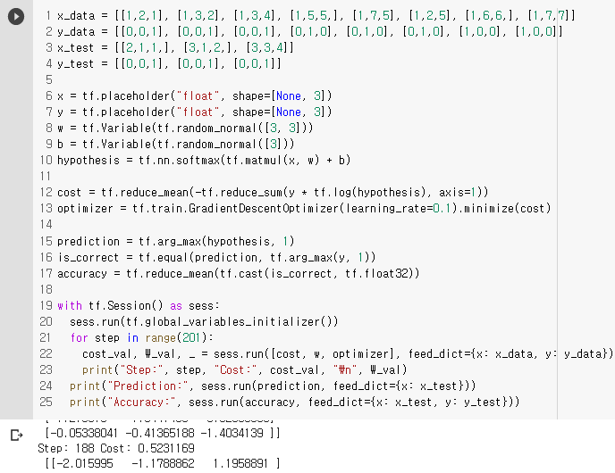

**Normalized Inputs Test.**

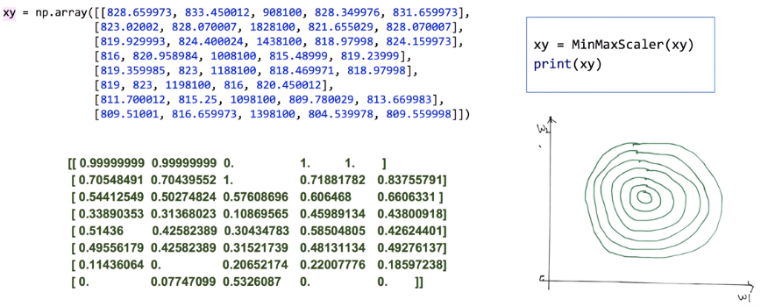

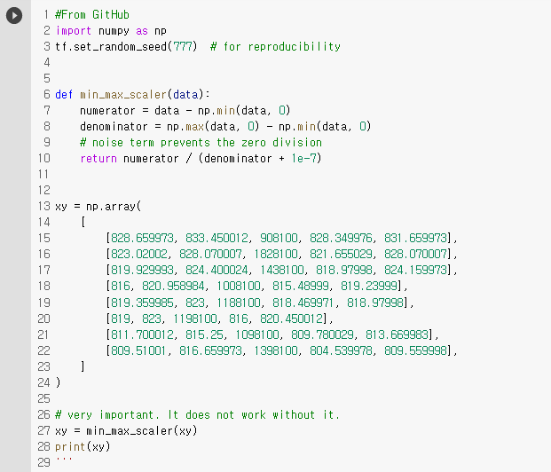

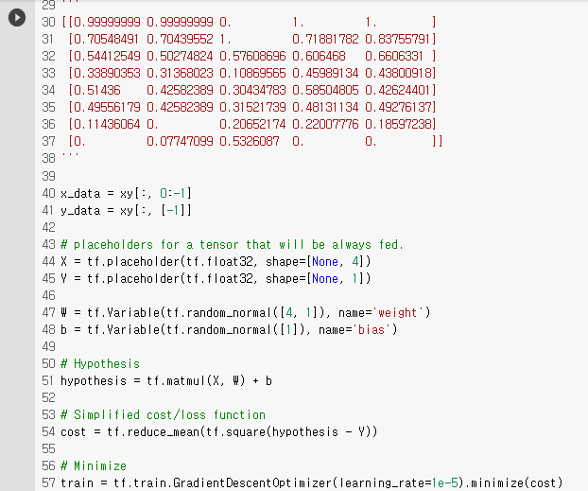

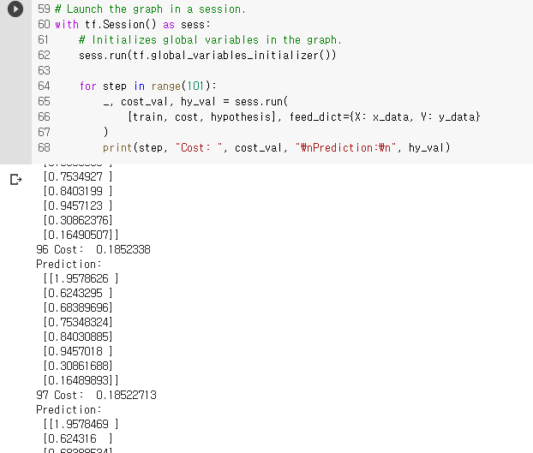

**ML_Lab 07-2.**

**Training Epoch & Batch.**

1. One Epoch : One forward pass and one backward pass of all the training examples
2. Batch Size : The number of training examples in one forward/backward pass. The higher the Batch Size, the more memory space you’ll need.
3. Number of Iterations : number of passes, each pass using [Batch Size] number of examples. To be clear, one pass = one forward pass + one backward pass (we do not count the forward pass and backward pass as two different passes).

Example : If you have 1000 training examples, and your Batch Size is 500, then it will take 2 Iterations to complete 1 Epoch.

**MNIST Dataset Test.**

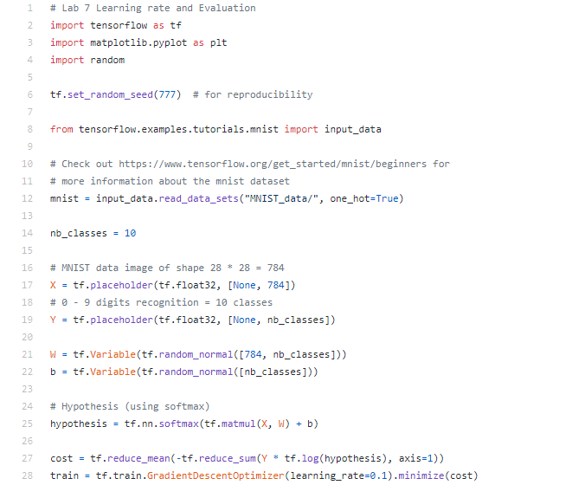

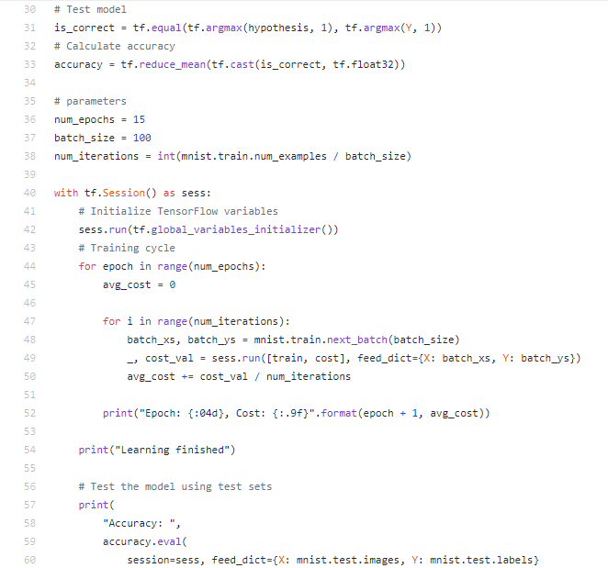

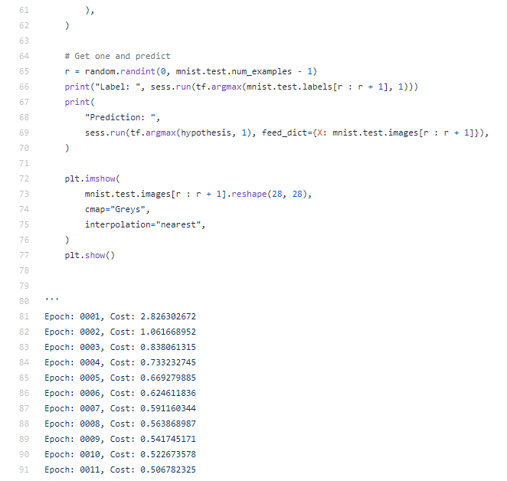

//From GitHub, Memo.보류

**ML_Lec 08-1.**

**Activation Functions. //From a Neuron**

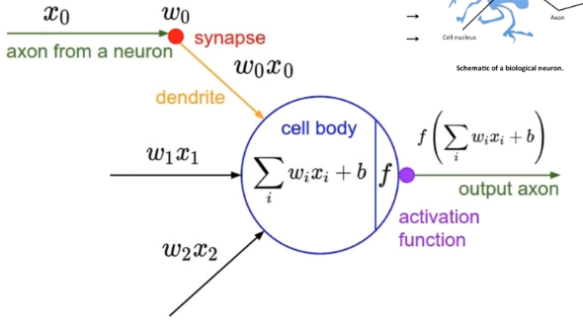

**Logistic Regression Units.**

전에 언급한 내용을 통해 여러 개의 출력을 동시에 낼 수 있다.

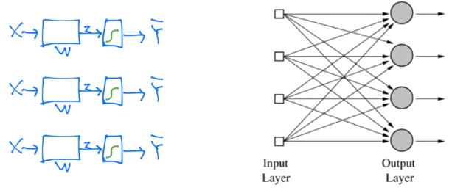

**Hardware Implementations.**

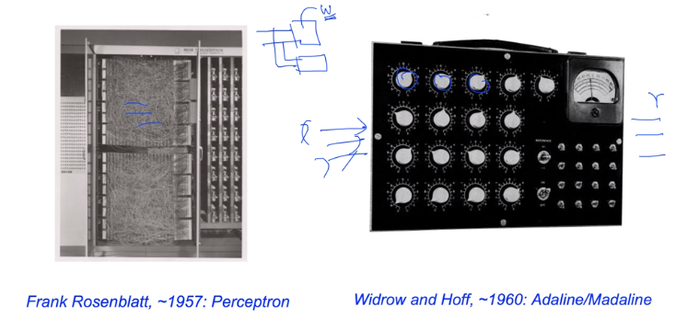

**AND/OR/XOR Problem: Linearly Separable? (Simple).**

AND/OR은 되나 XOR은 불가능하다.

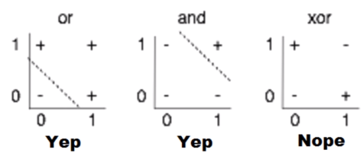

**Perceptrons. //1969 by Marvin Minsky, founder of the MIT AI Lab**

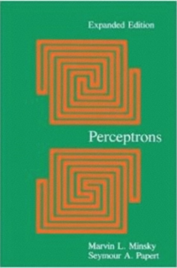We need to use MLP, multilayer perceptrons (multilayer neural nets)

No one on earth had found a viable way to train MLPs good enough to learn such simple functions.

**Backpropagtion. //역전파 //1974, 1982 by Paul Werbos, 1986 by Hinton**

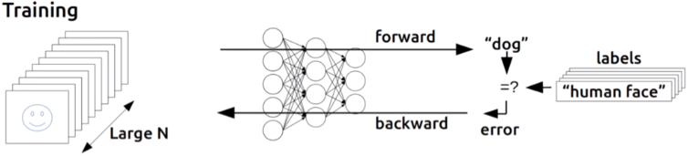

**Convolutional Neural Networks. //1959 by Hubel & Wiesel**

1. 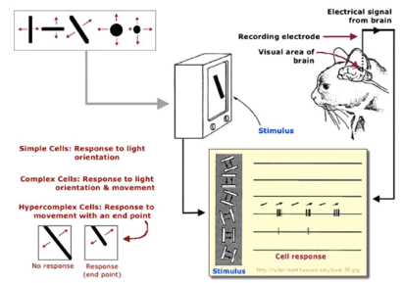
2. 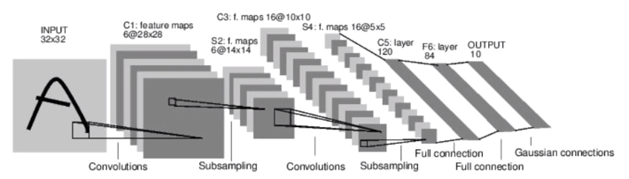

**A BIG Problem.**

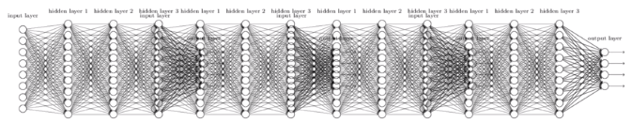

1. Backpropagation just did not work well for normal neural nets with many layers
2. Other rising machine learning algorithms: SVM, RandomForest, etc.
3. 1995 “Comparison of Learning Algorithms For Handwritten Digit Recognition” by LeCun et al.found that this new approach worked better.

**ML_Lec 08-2.**

**Breakthrough. //In 2006 and 2007 by Hinton and Bengio**

1. Neural networks with many layers really could be trained well, if the weights are initialized in a clever way rather than randomly.
2. Deep machine learning methods are more efficient for difficult problems than shallow methods.
3. Rebranding to Deep Nets, Deep Learning.

**ImageNet Classification. //2010 – 2015**

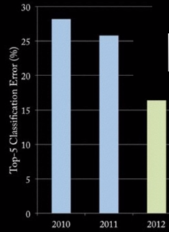// Error 26.2% to 15.3%

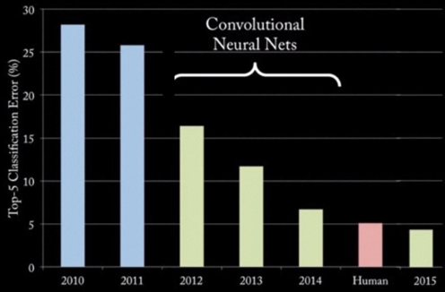

**Neural Networks That Can Explain Photos.**

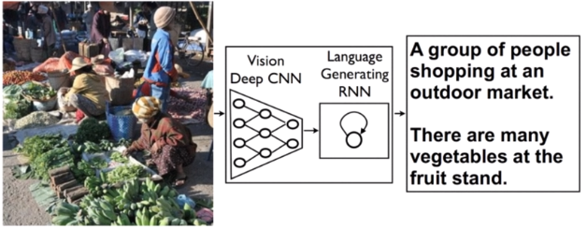

**Deep API Learning.**

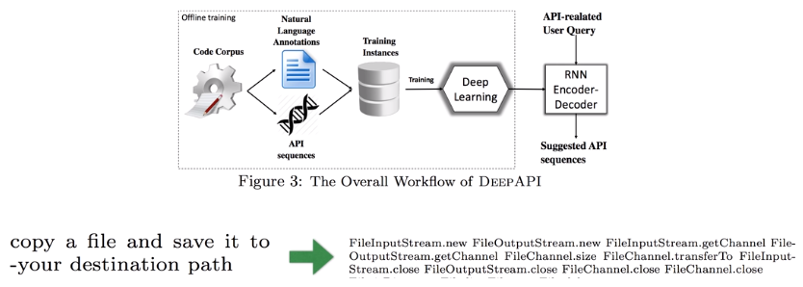

**Geoffrey Hinton’s Summary of Findings Up to Today.**

1. Our labeled datasets were thousands of times too small.
2. Our computers were millions of times too slow.
3. We initialized the weights in a stupid way.
4. We used the wrong type of non-linearity.

**ML_Lab 08.**

Tensor Manipulation.

**Simple ID Array and Slicing Test.**

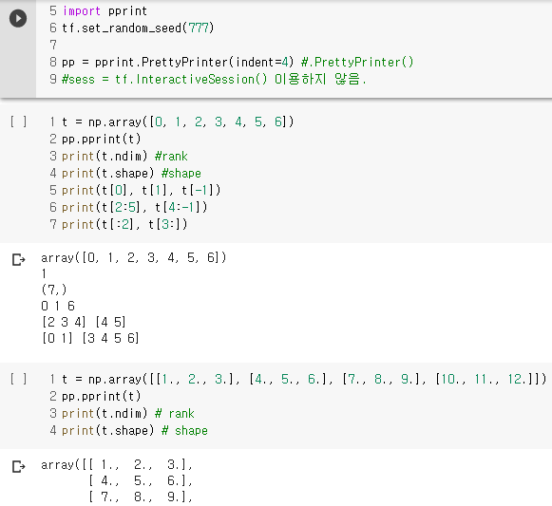

**Shape, Rank, Axis Test.**

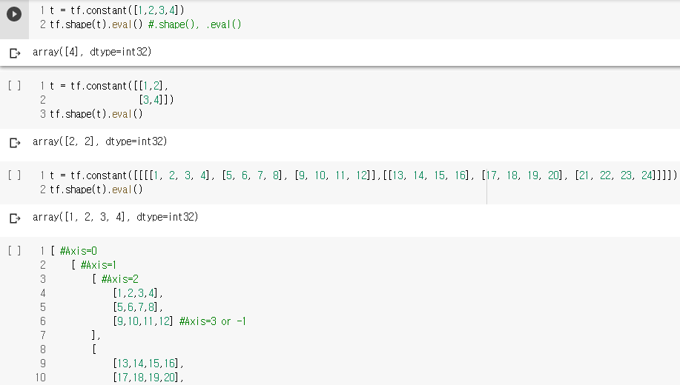

**Matmul & Multiply Test.**

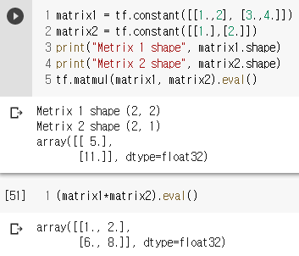

**Broadcasting Test.**

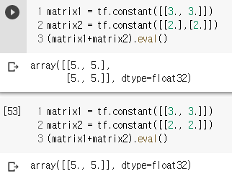

**Reduce_mean Test.**

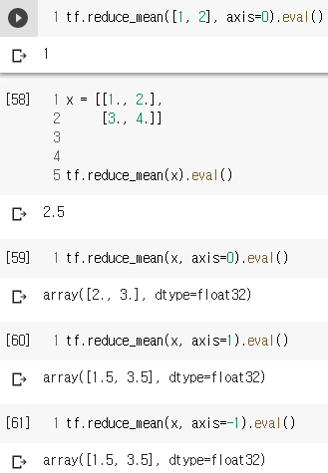

**Reduce_sum Test.**

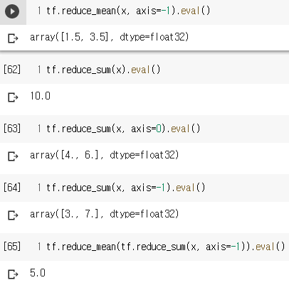

**Argmax Test.**

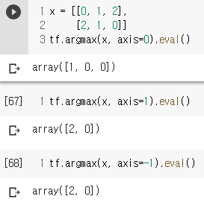

**Reshape Test.**

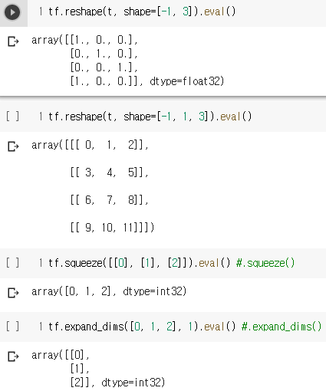

**One_hot Test.**

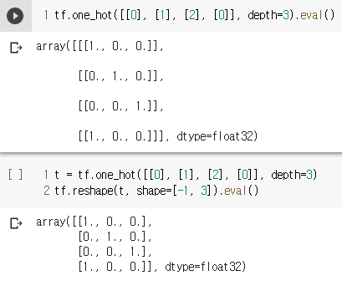

**Stack Test.**

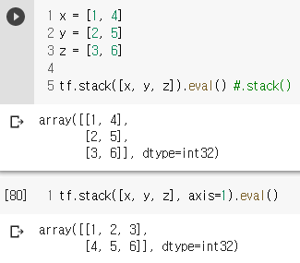

**Casting Test.**

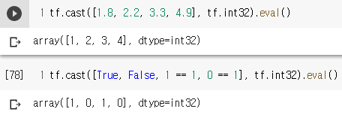

**Ones_like & Zeros_like Test.**

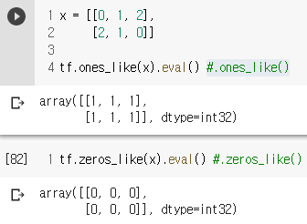

**Zip Test.**

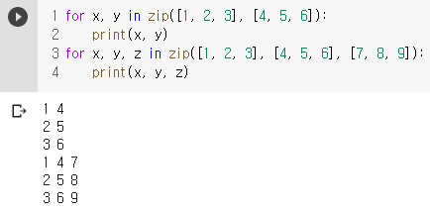

**ML_Lec 09-1.**

**XOR Problem Using Neural Net(NN).**

1. Multiple Logistic Regression Units.

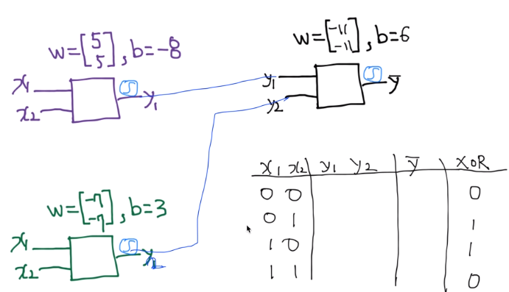

1. 계산 과정.

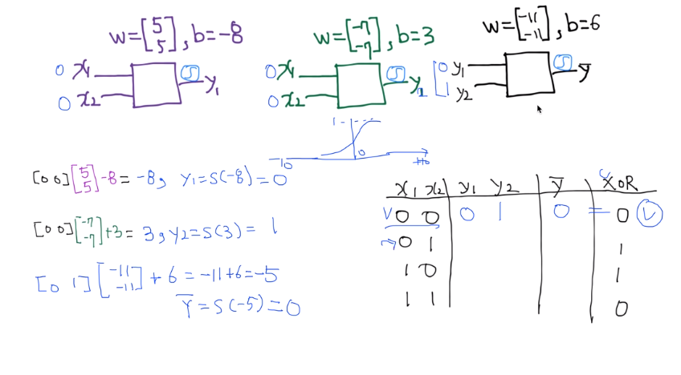

1. $x_{1}, x_{2}$ 를 대입하여 Sigmoid Function으로 $y_{1}, y_{2}$ 를 얻는다.
2. $y_{1}, y_{2}$ 를 대입하여 Sigmoid Function으로 $\overline{y}$ 를 얻는다.
3. $\overline{y}$ 와 XOR의 값을 확인한다.

**Forward Propagation. //순전파**

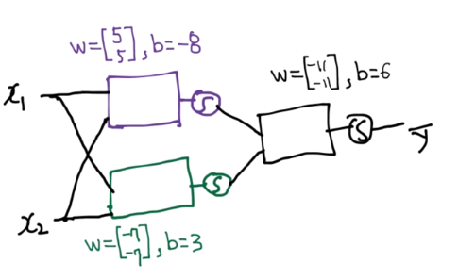

↓↓↓↓↓↓↓↓↓↓

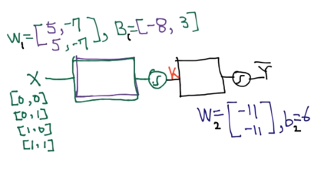

**ML_Lec 09-2.**

**Derivation.**

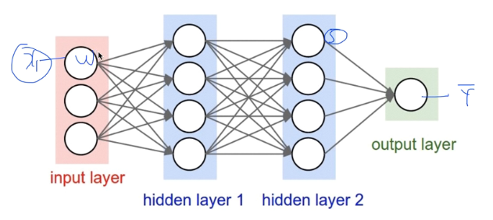

**Backpropagation(Chain Rule). //역전파(합성함수의 미분)**

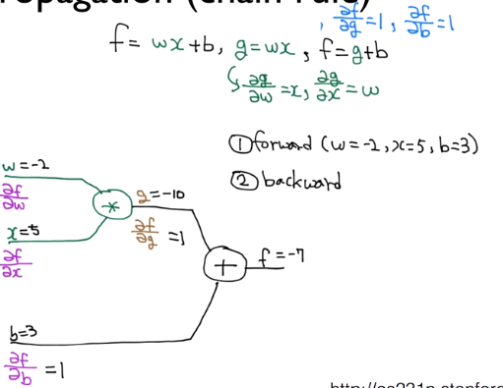

=-2

=5

**ML_Lab 09-1.**

**Test.**

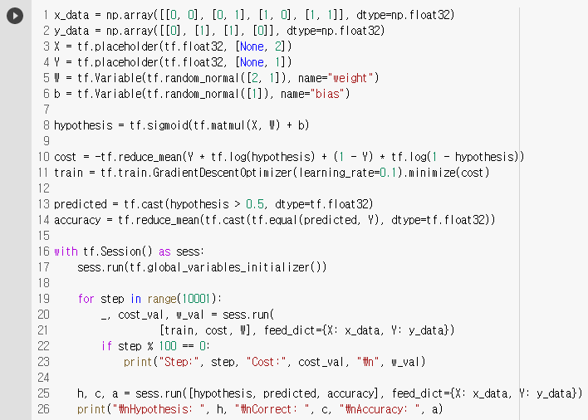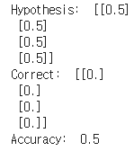

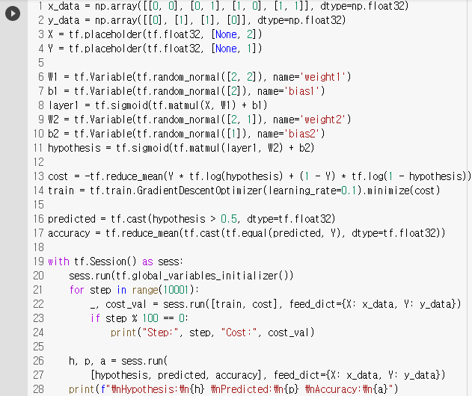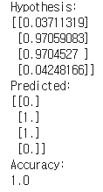

**ML_Lab 09-2.**

**Test.**

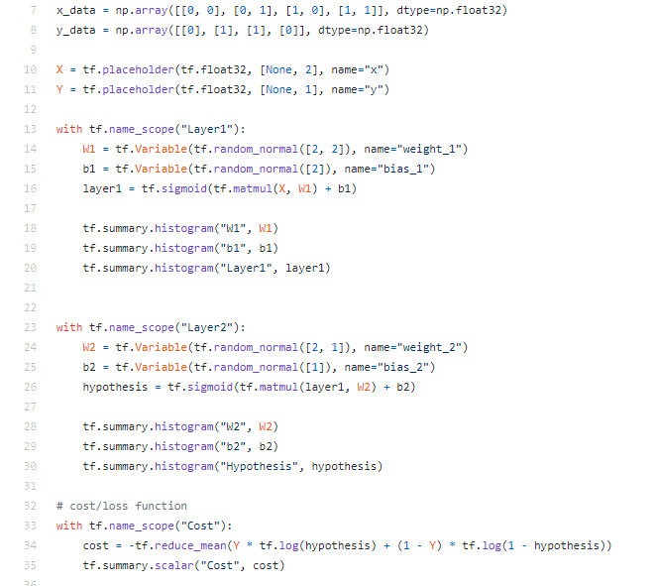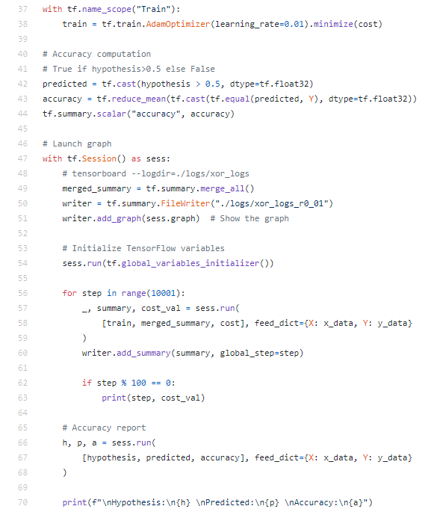//From GitHub, Memo.보류

**ML_Lec 10-1.**

**Vanishing gradient. //NN winter2: 1986-2006.**

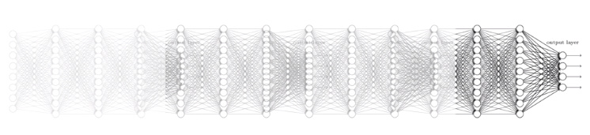

**ReLU: Rectified Linear Unit.**

Code: L1 = tf.nn.relu(tf.matmul(X, W1) + b1)

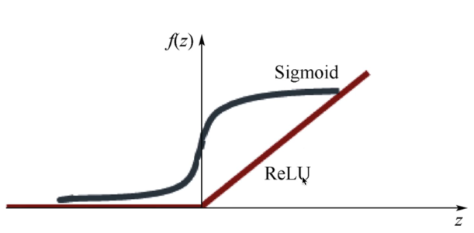

**Cost Function.**

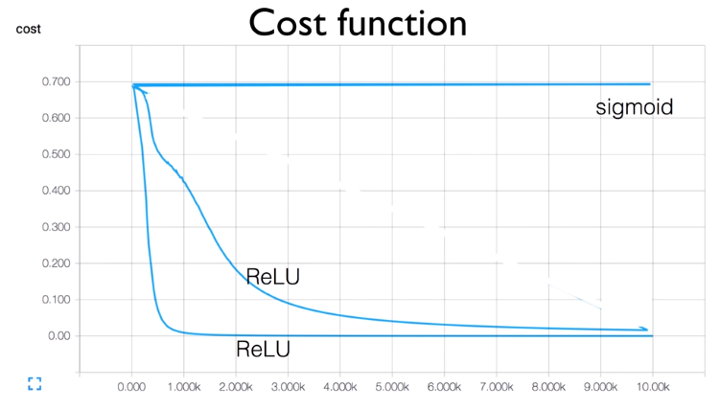

**Other Activation Functions.**

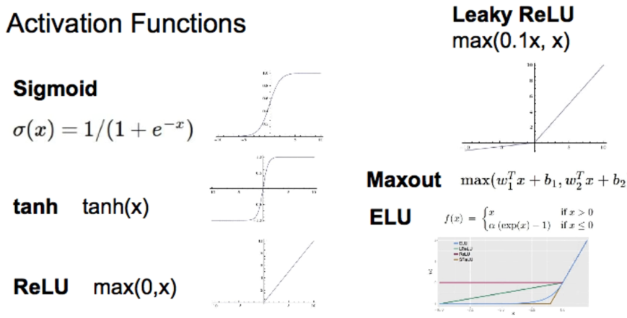

**ML_Lec 10-2.**

**Need to Set the Initial Weight Values Wisely.**

1. Not all 0’s
2. Challenging issue
3. Hinton et al. (2006) “A Fast Learning Algorithm for Deep Belief Nets”-RBM

**RBM(Restricted Boatman Machine) Structure.**

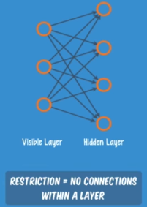 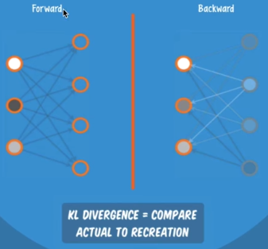

1. Forward를 통한 x값과 Backward를 통한 x를 비교한다.
2. 가장 차이가 적도록 Weight를 조정한다.

**Xavier/He Initialization.**

1. Makes sure the weights are ‘just right’, not too small, not to big
2. Using number of input (fan in) and output (fan out)
3. Code: W = np.random.randn(fan_in, fan_out)/np.sqrt(fan_in) //by 2015. (fan_in/2)

**ML_Lec 10-3.**

**Dropout. //A Simple Way to Prevent NN from Overfitting (Srivastava et al.2014)**

“randomly set some neurons to zero in the forward pass.”

Code: L1 = tf.nn.dropout(_L1, dropout_rate)

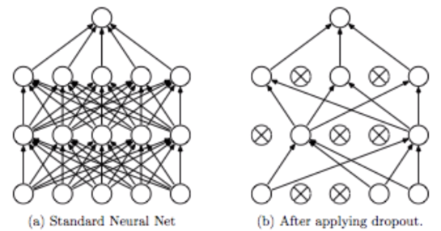

**Ensemble.**

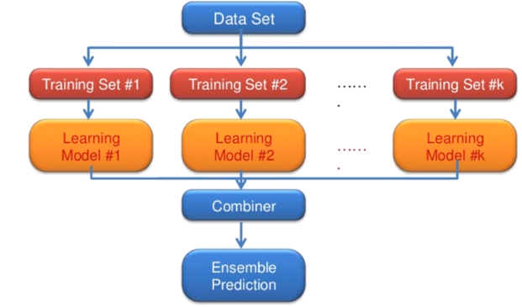

**ML_Lec 10-4.**

NN LEGO Play.

**Fast Forward.**

신호를 앞으로 당겨 계산한다.

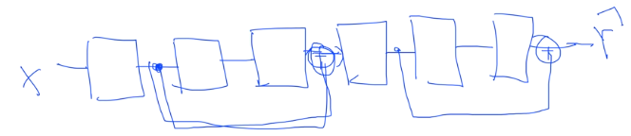

**Split & Merge.**

나뉘어 계산을 하고 나중에 모인다.

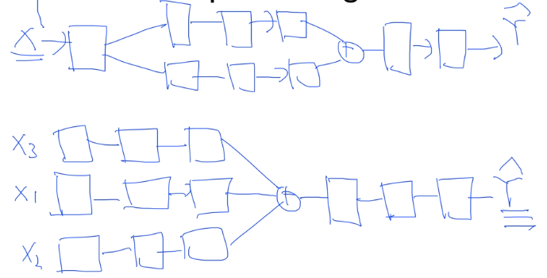

**Recurrent Network(RNN).**

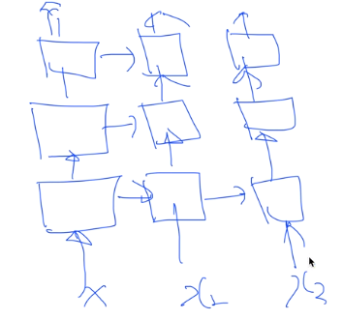

**ML_Lab 10.**

**NN for MNIST Test. //Memo.보류**

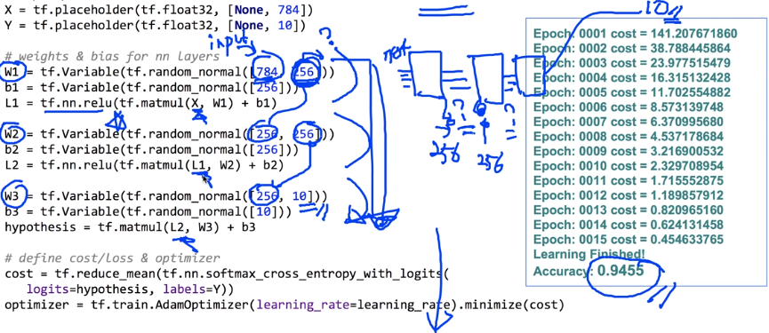

**Xavier for MNIST Test. //Memo.보류**

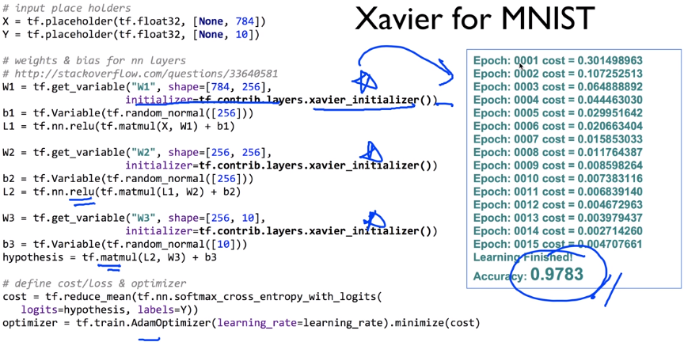

**Deep NN for MNIST Test. //Memo.보류**

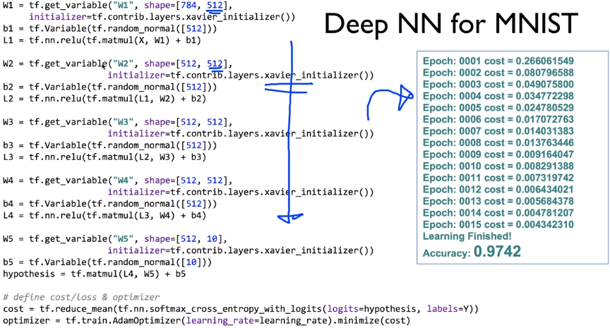

**Dropout for MNIST Test. //Memo.보류**

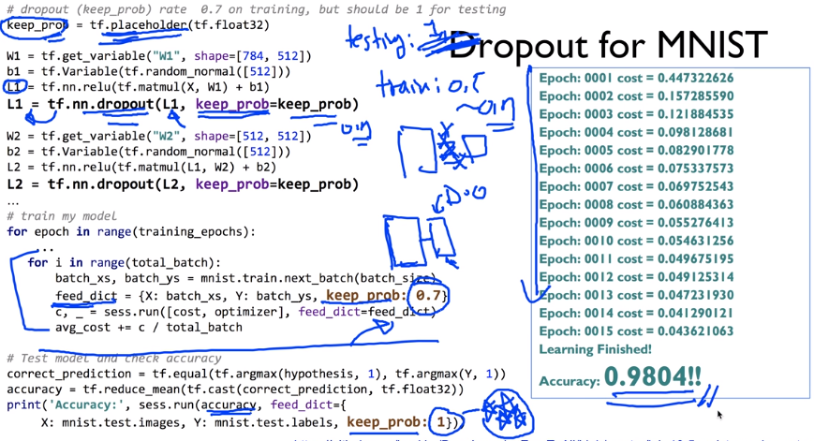

**Optimizer.**

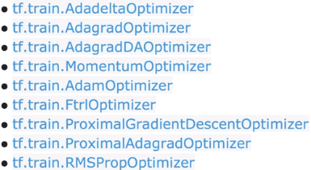

**ADAM. //A Method for Stochastic Optimaization (Kingma et al.2015)**

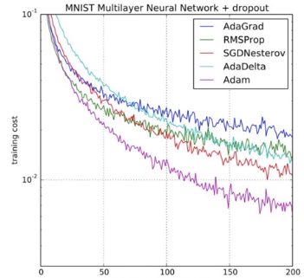

**ML_Lec 11-1.**

**Convolutional Neural Networks. //1959 by Hubel & Wiesel**

1. 
2. 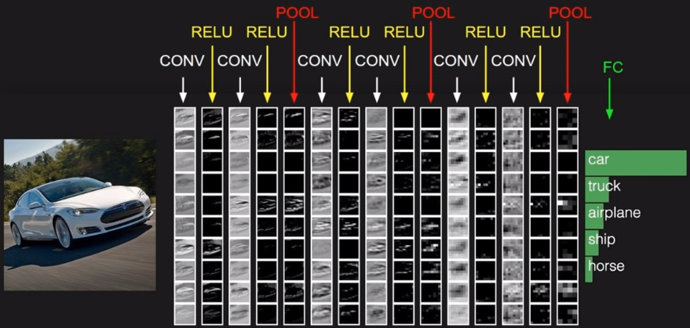

**ConvNet. CNN.**

1. 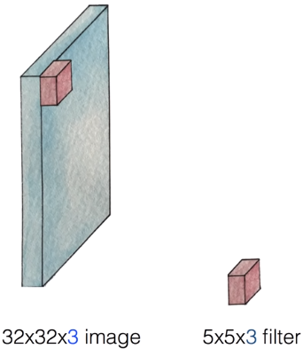
2. 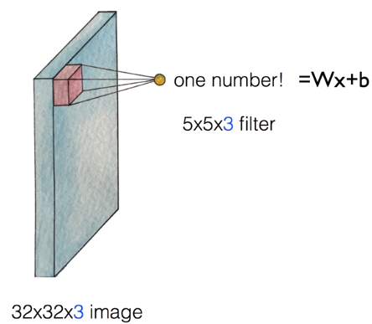
3. 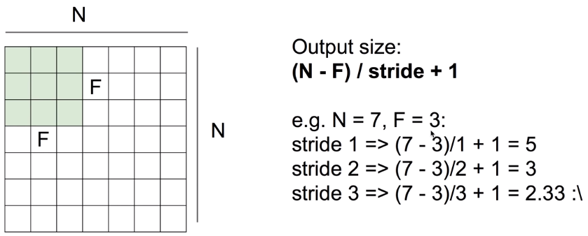

padding

1. 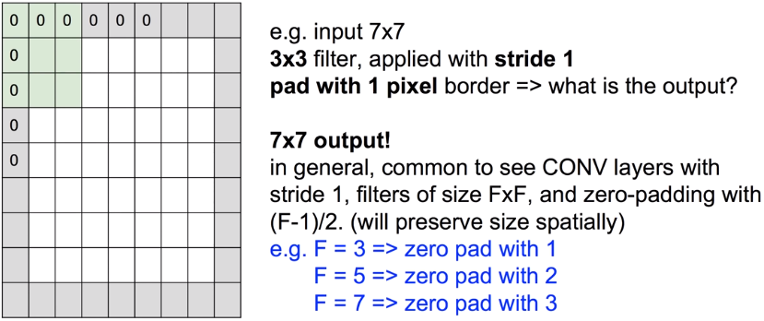
2. 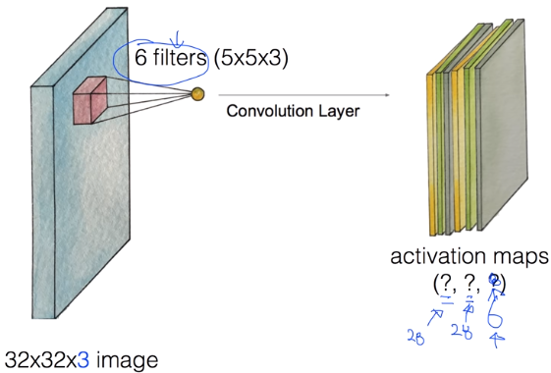//(32-5)/1+1=28
3. 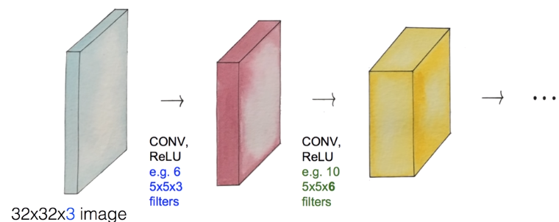//w=5x5x3x6

**ML_Lec 11-2.**

**Pooling Layer (Sampling).**

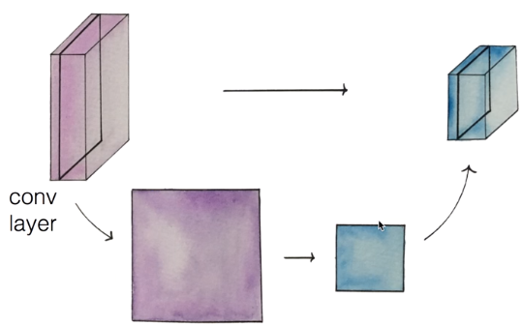

**Max Pooling.**

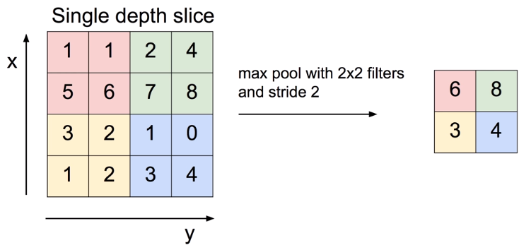

**Fully Connected(FC) Layer.**



**ML_Lec 11-3.**

ConvNet의 활용.

**AlexNet. //Krizhevsky et al.2012**

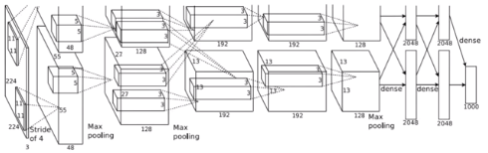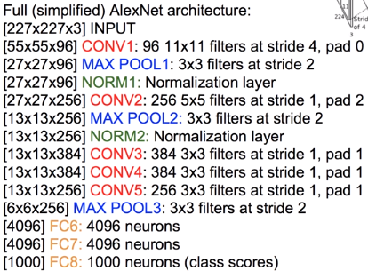

1. Input: 227x227x3 Images
2. First Layer(CONV): 96 11x11 Filters applied at Stride 4
3. Output Volume: 55x55x96
4. Parameters: (11*11*3)*96 = 35K
5. Second Layer(FOOL): 3x3 Filters applied at Stride 2
6. Output Volume: 27x27x96
7. Parameters: 0!
8. NORM: Normalization Layer
9. 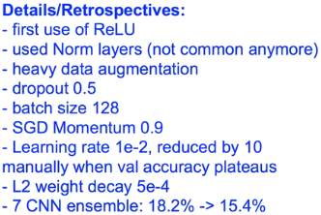

**GoogLeNet. //Szegedy et al.2014**

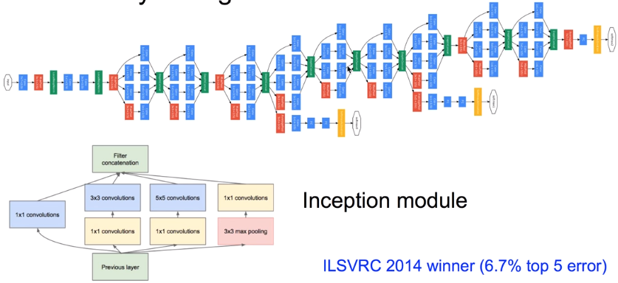

**ResNet //He et al.2015**

1. 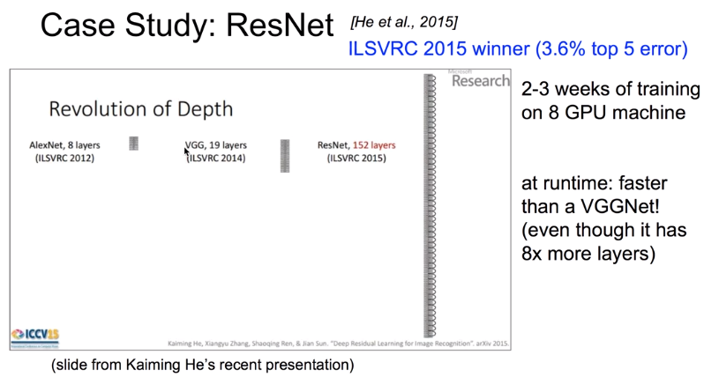
2. 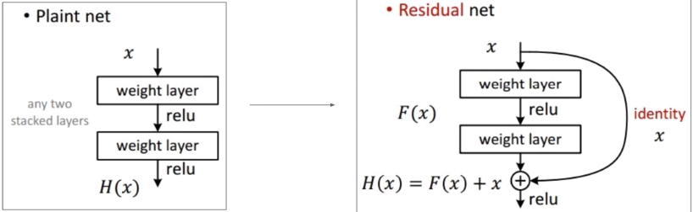//Fast Forward

**Sentence Classification. //Yoon Kim, 2014**

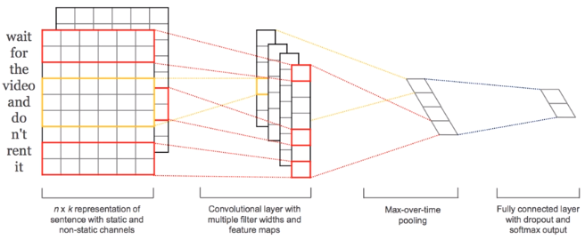

**DeepMind’s AlphaGo.**

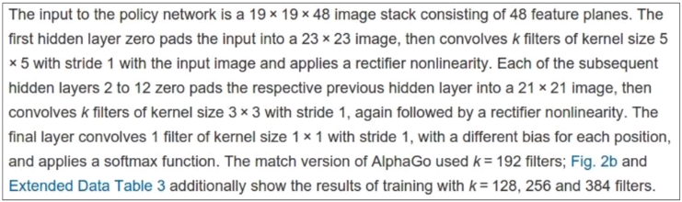

Policy Network:

1. [19x19x45] Input
2. CONV1: 192 5x5 Filters, Stride1, Pad2, [19x19x192]
3. CONV2…12: 192 3x3 Filters, Stride1, Pad1, [19x19x192]
4. CONV: 1 1x1 Filters, Stride1 ,Pad0, [19x19]

**Memo.**

.constant() //상수

.Session() //tensor에 데이터를 넣어 흐르게 함.

.run() //실행

.add() //더하기

.placeholeder(), feed_dict={a:a_data} //변수, 값을 나중에 할당.

.Variable() //변수, 자동으로 업데이트.

.random_normal(Shapes) //랜덤 값 반환

.reduce_mean() //평균

.square() //제곱

.GradientDescentOptimizer() //미니 배치 확률적 경사하강법(SGD) 구현.

.minimize() //최소화

.global_variables_initializer() //.Variable()를 초기화.

.append() //append

.plot() //plot

.show() //show

.reduce_sum() //총합

.assign() //.Variable()의 값 변경.

.compute_gradients() //compute_gradients

.apply_gradients() //apply_gradients

.matmul() //matmul

.loadtext() //text불러오기.

.set_random_seed() //랜덤 값 시드, 다른 환경에서도 같다.

.string_input_producer() //Queue, text를 Filename Queue에 쌓기.

.TextLineReader() //Queue, text를 Reader로 연결.

.read() //Queue, text읽기.

.decode_csv() //Queue, text decode

.batch() //Queue, text batch

.Coordinator() //Queue, Coordinator생성.

.start_queue_runners() //Queue, Queue를 Thread로 시작.

.request_stop() //Queue, 중지

.join() //Queue, 대기

.sigmoid() //S자 곡선

.log() //로그

.cast() //새로운 자료형

.equal() //값이 같은지

.softmax() //softmax

.arg_max() //arg_max

.one_hot() //one_hot

.reshape() //reshape

.softmax_cross_entropy_with_logits() //softmax_cross_entropy_with_logits

.format() //format

.flatten() //flatten

.PrettyPrinter() //PrettyPrinter

.InteractiveSession() //InteractiveSession

.array() //Array

.shape() //Shape

.eval() //Eval

.squeeze() //Array 정리

.expand_dims() //Array 정렬

.stack() //Array 쌓기

.ones_like() //One으로 바꿈.

.zeros_like() //Zero로 바꿈.

zip() //Zip

.nn.relu() //Relu

.random.randn() //지정 범위 내 랜덤 값 반환

.nn.dropout() //Dropout

//Lab으로 연결 https://colab.research.google.com/drive/1gaTpEufmhoK2CsEsNyfDDtyynQ_HRpSu

//14폰트, 12폰트, 10폰트

//1. 1) a. *♠

//0.71 1.34